## References

* Run Background tasks with WebJobs

<https://docs.microsoft.com/en-us/azure/app-service-web/web-sites-create-web-jobs>

* Create a .NET WebJob in Azure App Service

<https://docs.microsoft.com/en-us/azure/app-service-web/websites-dotnet-webjobs-sdk-get-started>

## Requirements

* Finished the part 11 of HOL
* Simulated Linux & Windows Wind turbines

## Goals

* Publish the Power BI Embedded Web App
* Add the Alarm Service Bus and Telemetry Event Processor Host projects to Azure Webjob
* Cloud deployment

## Step 1: Deployment for Power BI Embedded Web App

* Publish the **EmbedSample** Web App to Azure again.

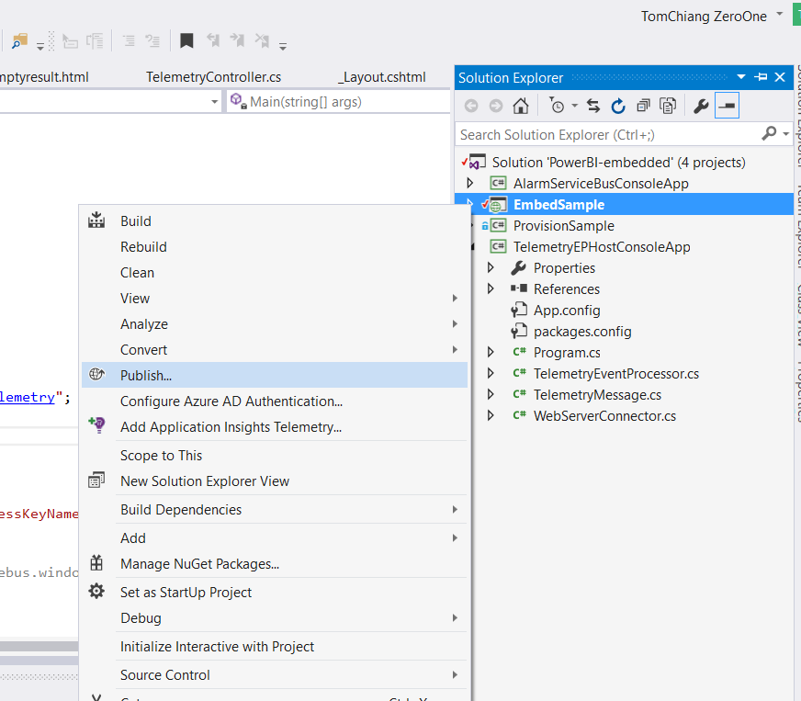

## Step 2: Publish the Alert Service Bus and Event Processor Host projects as Azure Webjob

* Close the **AlertServiceBus** and **TelemetryProcessor** projects first.
* Right-click the solution to **add** the **existing project**

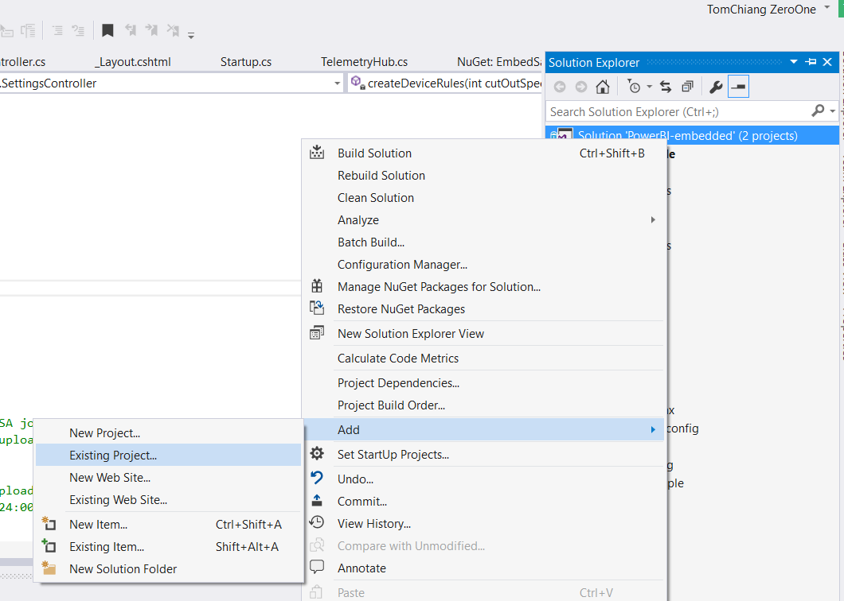

* Select the project file of **Alert Service Bus.**

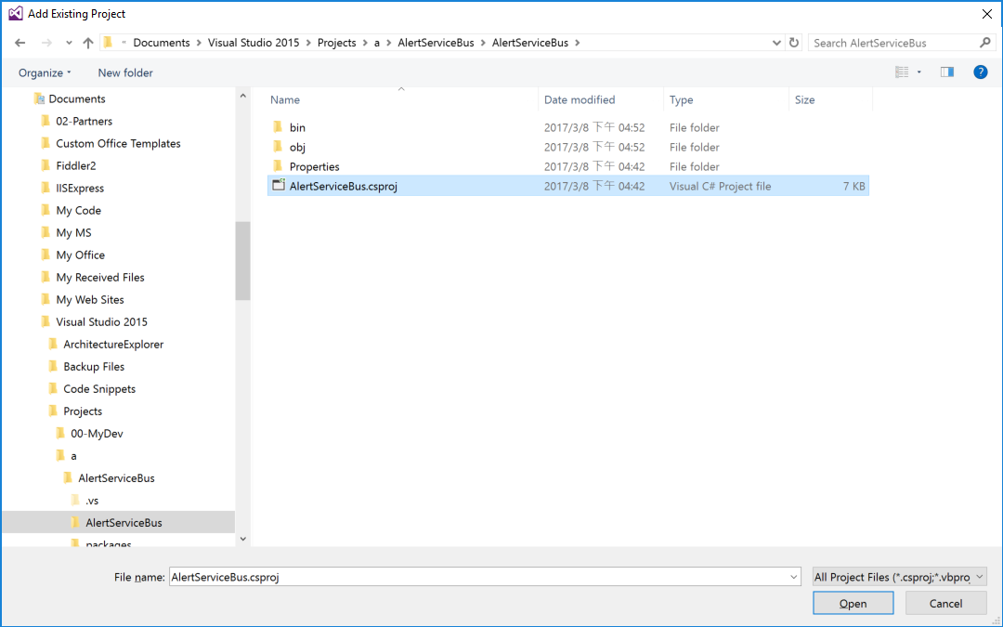

* Publish the **Alert Service Bus** as **Azure WebJob**

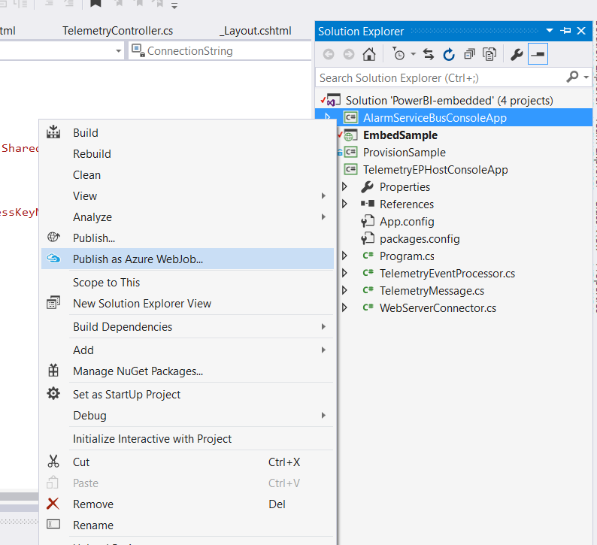

* Add Azure WebJob

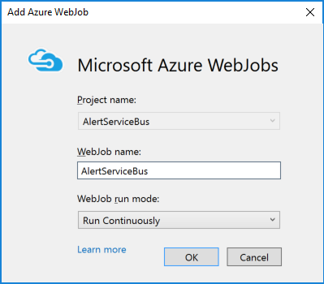

* Select the corresponded profile and resource group

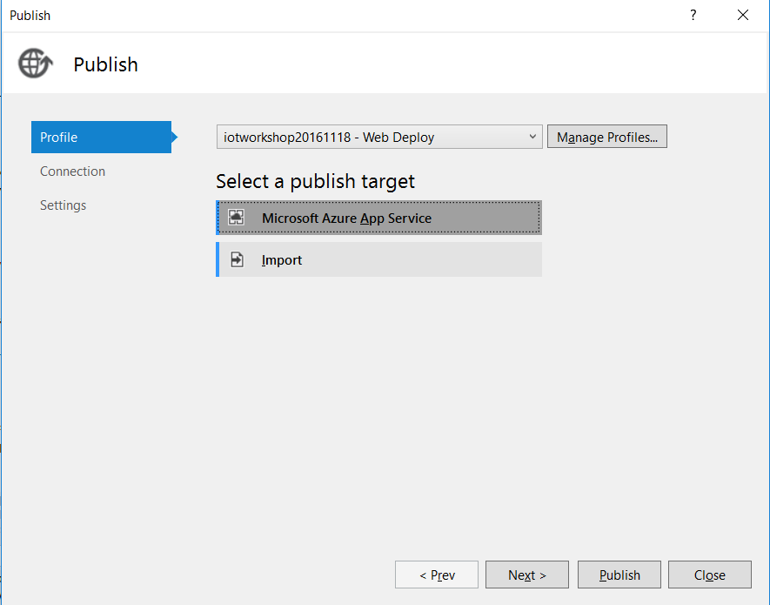

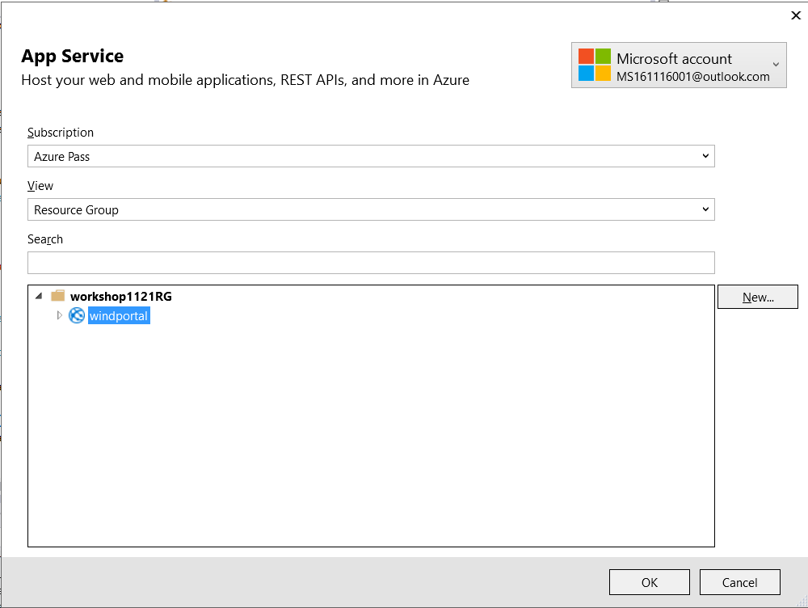

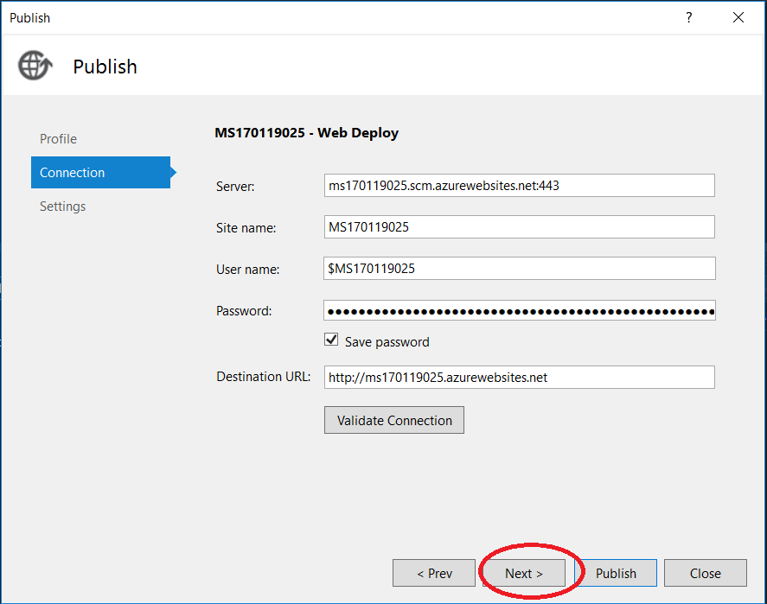

* Deploy to Azure

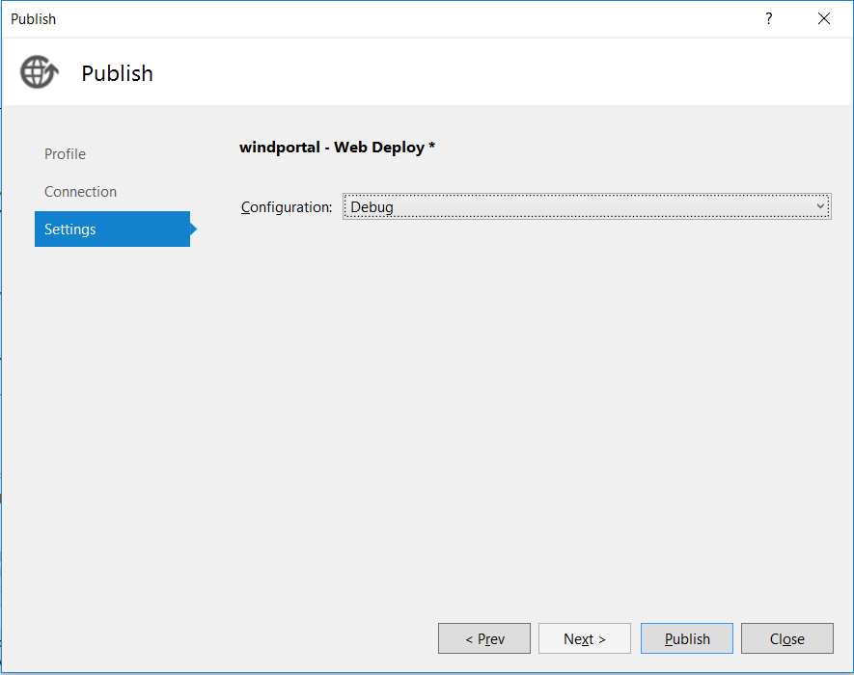

* Check the output window

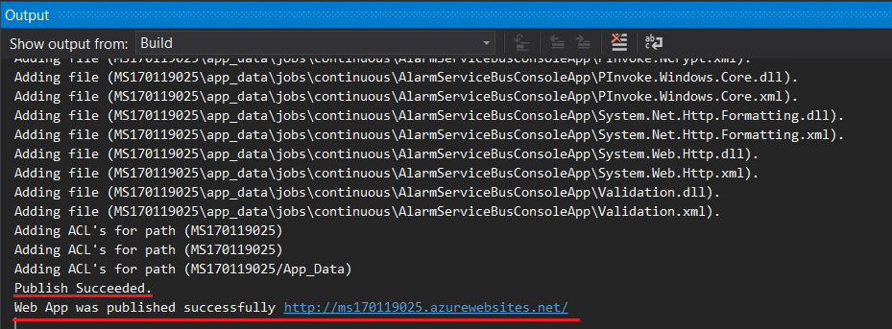

* Add the existing project for **Telemetry Processor**

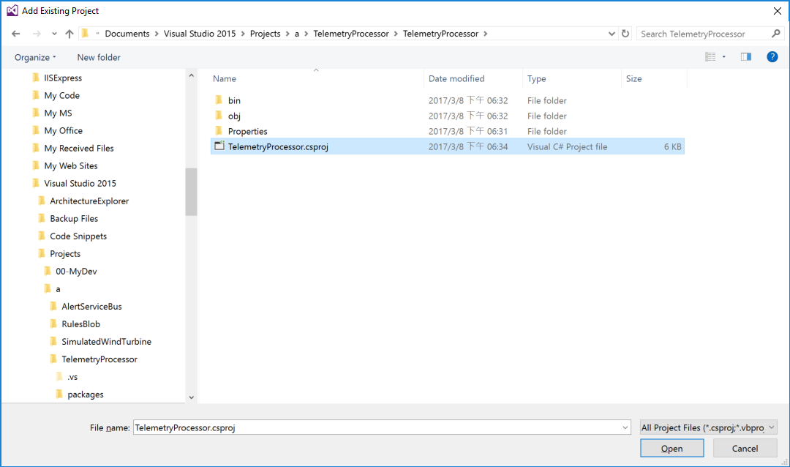

* Get the **URL** of web site

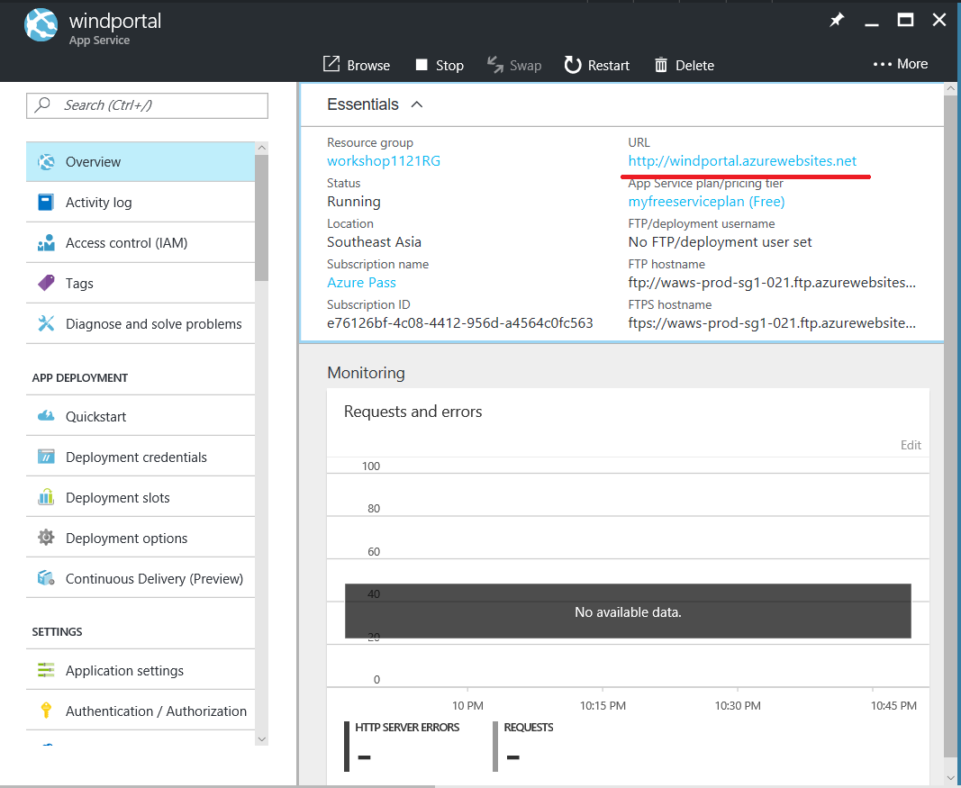

* Update the **App.config** in **TelemetryProcessor** project
* **WebServer.isProduction**: set the value to “**1”** for production
* **WebServer.Production**: the url of web site.

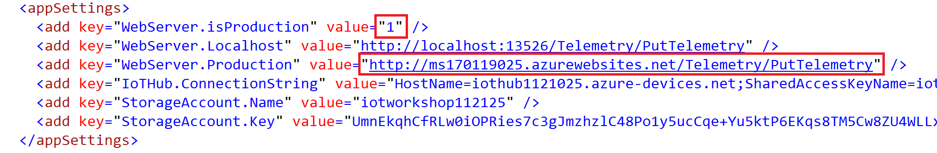

* Publish the **Telemetry Processor** as another **Azure WebJob again.**
* Add Azure WebJob

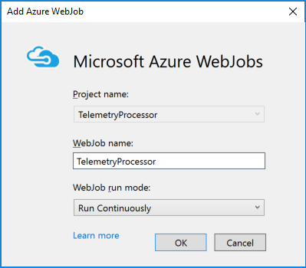

* Deploy to Azure and check the output.
* Now the production website is ready!

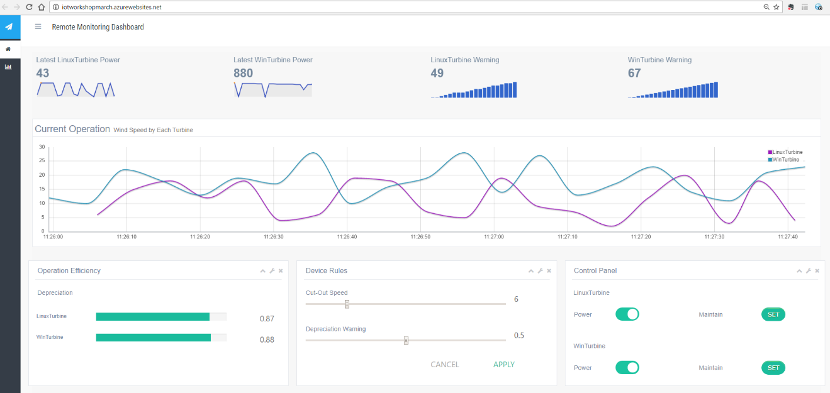

## Step 3: Watch the log of WebJob in Azure Portal

* Select the WebJob in WebApp

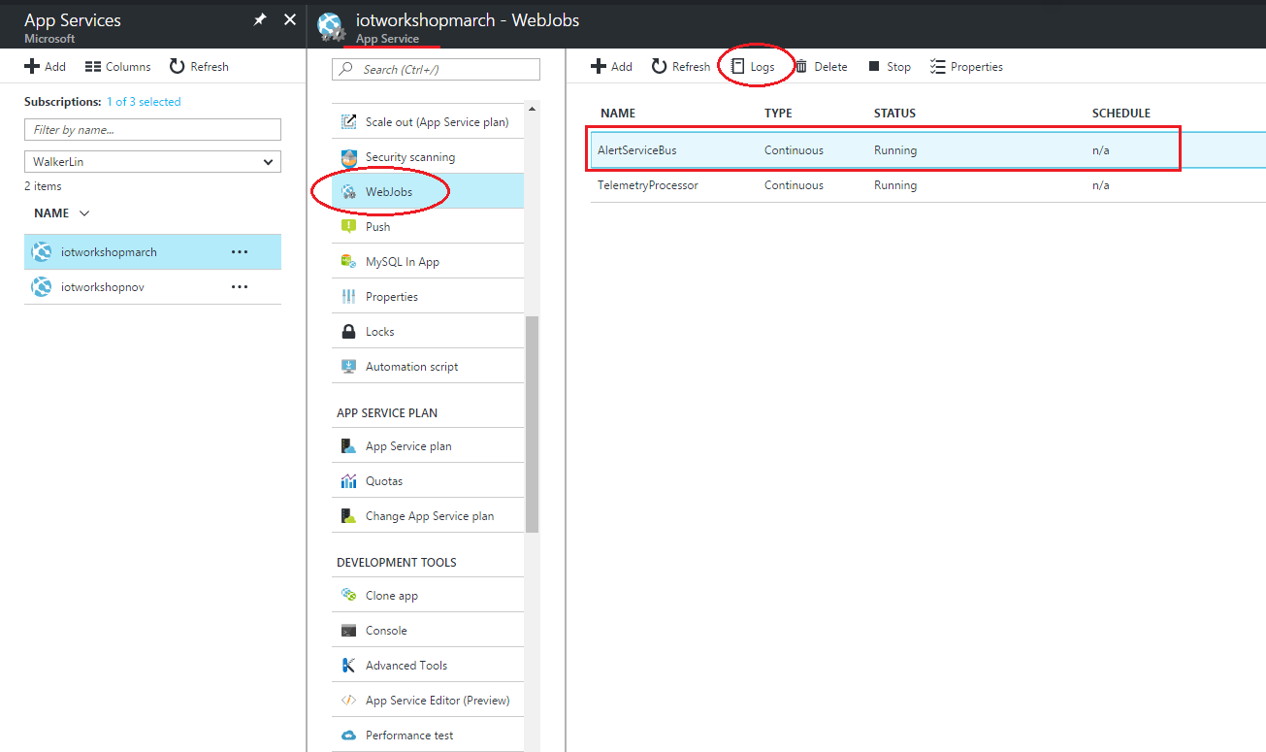

* Watch the logs of background tasks.

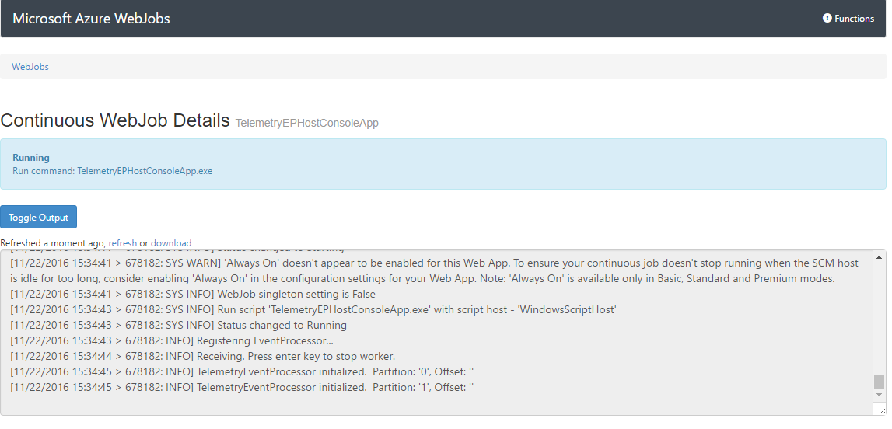

* *All HOLs has been completed. You have got a big progress in the IoT world, and learned how to start the implementation of a remote monitoring solution on Azure. We hope these training materials can help you to develop your project quickly and easily.*

*Finally, Thanks for your time and it’s appreciate to get your feedback soon.*